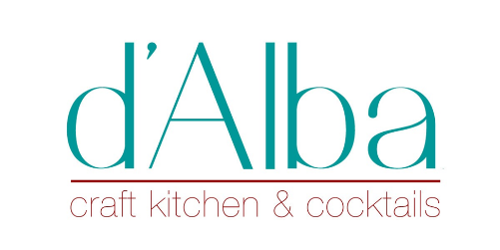
Wines by the Bottle
Sparkling
Henri Champliau Blanc de Burgundy 44.00
Piper Heidsieck Brut Champagne 82.00
Veuve Clicquot “Yellow Label” Brut Champagne 116.00
Perrier- Jouet Grand Brut Champagne 144.00
Tre Secoli Brachetto d’Acqui Brut Rosé 91 point rating- flavor of roses and strawberry 40.00
Drappier Rosé Champagne 119.00

White
Villa Sandi Pinot Grigio 2019 35.00
Cristia Cotes du Rhone Blanc 2020 – (Rhone Valley) -super plush style! 35.00
Ant Moore Sauvignon Blanc 2020 (Marlborough) 36.00
Karl Kaspar Mosel Riesling 2018 (Germany) 39.00
Maysara Arsheen Pinot Grigio 2018 (Willamette Valley) 41.00
Hoopes Hoopla Chardonnay 2018 (Napa) 48.00
Pierre Sparr Gewurztraminer 2018 (Alsace) 52.00
Ghost Block Sauvignon Blanc 2017 (Napa) 54.00
Benito Santos Albarino 2020 (Spain) 54.00
Michael David Chardonnay (Lodi) 56.00
Houston Winery Vermentino (Texas) 62.00
Stone Castle Reserve Chardonnay (Kosovo) 62.00
Langlois Chateau Sancerre 2018 (Loire Valley) 66.00
Poseidon Oaked Chardonnay 2017 (Carneros) 68.00
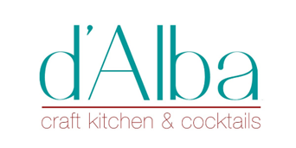
Reds by the Bottle
Peirano Zinfandel 2018 (Lodi) 36.00
Stone Castle Rahovec Vranac 2017 (Kosovo) 38.00
Rotation Cellars Cabernet Sauvignon 2018 (California) 39.00
Due Mari “la Chiusa” Negroamaro 2017 (Puglia, Italy)-93 point rated! 39.00
Le Naturel Grenache 2020 (Spain) 44.00
Saffron Fields Pinot Noir (Willamette Valley) - Houston owners! 45.00
Bodegas Lan Rioja Reserva (Spain) 49.00
Chateau Fort Lignac 2016 (Bordeaux) – owned by 2nd Growth Ducru Beaucaillou! 50.00
Mouton Cadet Heritage 2015 (Bordeaux) 55.00
J Dusi Zinfandel “Dante Dusi Vineyard” 2018 (Paso Robles)- 92 point rated! 55.00
Pascal Aufranc Juliénas Gamay “Probus” 2015 (Burgundy)- 92 point rated Burgundy! 55.00
One Stone Cellars Cabernet Sauvignon (Paso Robles) 55.00
Four Graces Pinot Noir 2019 (Willamette Valley) 58.00
Pertinace Dolcetto d’Alba 2018 (Piedmont) 55.00
Amity Vineyard Pinot Noir 2016 (Willamette Valley) 60.00
J Christopher Pinot Noir 2017 (Willamette Valley) 64.00
Enzo Boglietti Barbera d’Alba 2018 (Piedmont) 69.00
La Spinetta Terre di Pisa Sangiovese (Tuscany) 67.00
Balade by Belle Glos 2019 (Russian River) 72.00
De Forville Barbaresco 2018 (Piedmont) 78.00
Au Bon Climat Santa Maria Pinot Noir 2019 (Santa Maria Valley) 79.00
Cristia Chateauneuf du Pape 2018 (France) – 91 point rated, super rich! 85.00
Cadence Cabernet “Tapteil Vineyard” 2017 (Washington)-94 point rated! 95.00

Red Wines (continued)

Tamber Bey Cabernet 2018 (Napa) 124.00
Ciacci Picolomini Brunello 2016 (Tuscany) 138.00
Cross Barn Cabernet 2017 (Napa) 152.00
Gecaj Estate Owner’s Blend 2016 (Kosovo) 154.00
Orin Swift “Papillon” (Napa) 154.00
Ghost Block Cabernet 2017 (Oakville) 166.00
Silver Oak Alexander Valley 2017 (Sonoma) 168.00

